2014-2015

SharePoint Directions / Uploading to a Student Site
1. Open Internet Explorer by clicking the blue e in the bottom task bar

2. Click STUDENTS in the top red bar, then select SharePoint from the drop down menu.

3. Click My Student Site on the right side of the page (above the school picture)

4. Click My Documents in the left column

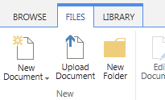
5. Click FILES in the top menu bar.

6. Click Upload Document

7. Click Browse

8. Select the assignment you want to upload.
9. Once the assignment you want to upload
is in the File name box, click Open.

10. Click OK on the next screen.
11. Check that your document is now in your
list of files! Look for the NEW next to your document!
Medusa

